List the general categories of data types in SQL Server.

Show the SQL command required to create a table called ***Employees*** with the following attributes: (Note: Choose appropriate data types for the columns) *Name*, *Age*, *Address*, *Salary*, *PPS*_*Number*, *Date_of_Birth*.

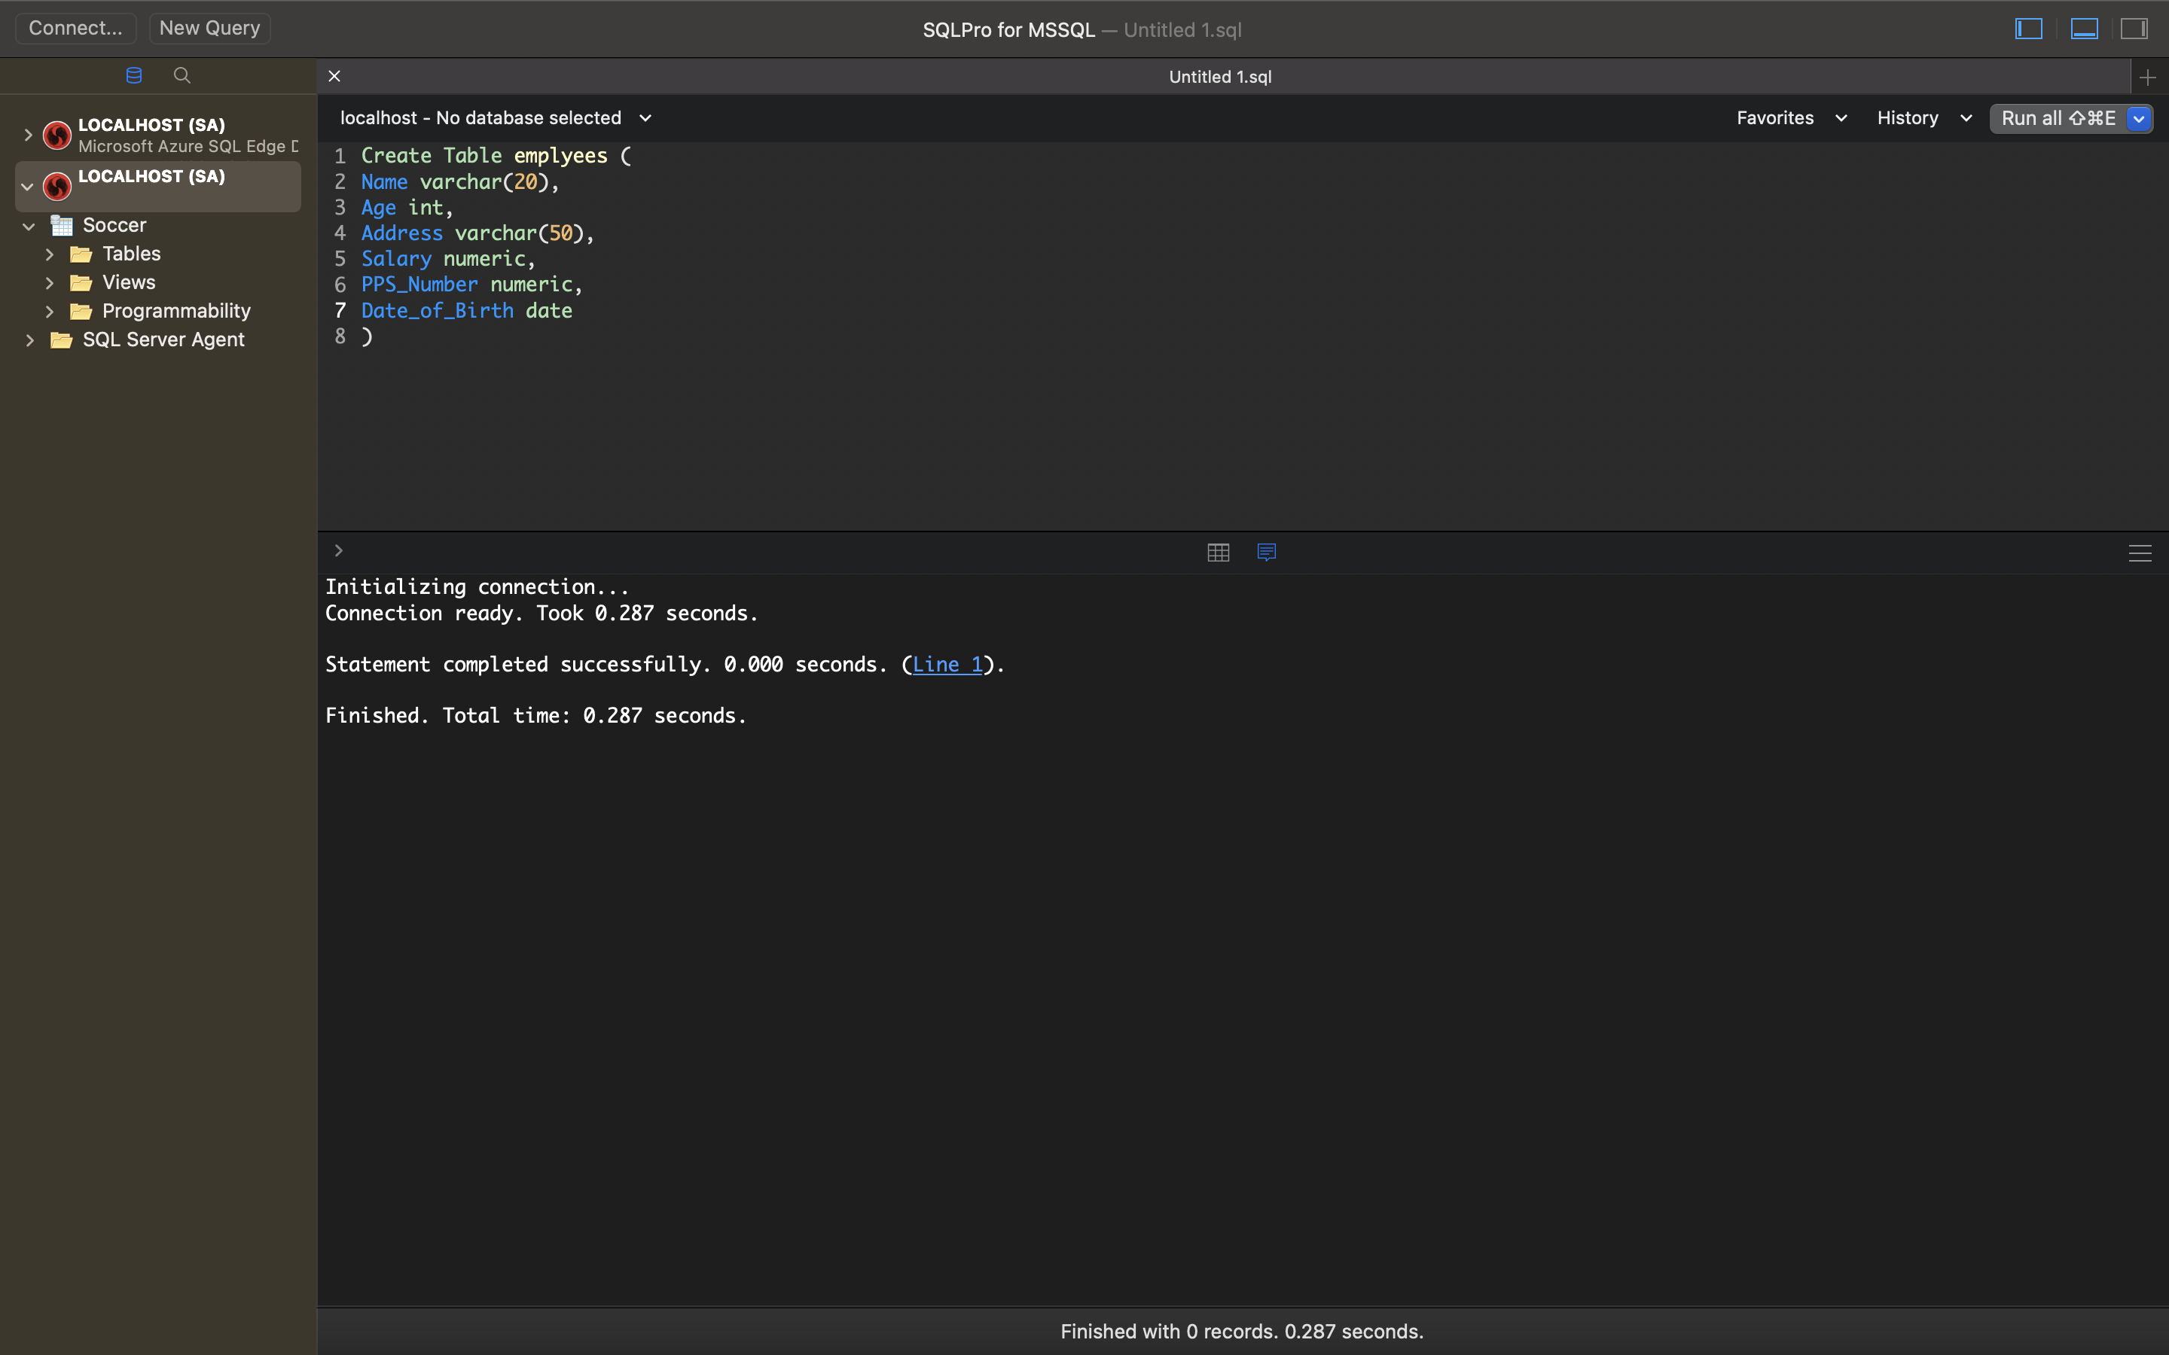

Show the SQL command required to create a View called ***v_Employees*** that will display the name, age and salary of all employees. 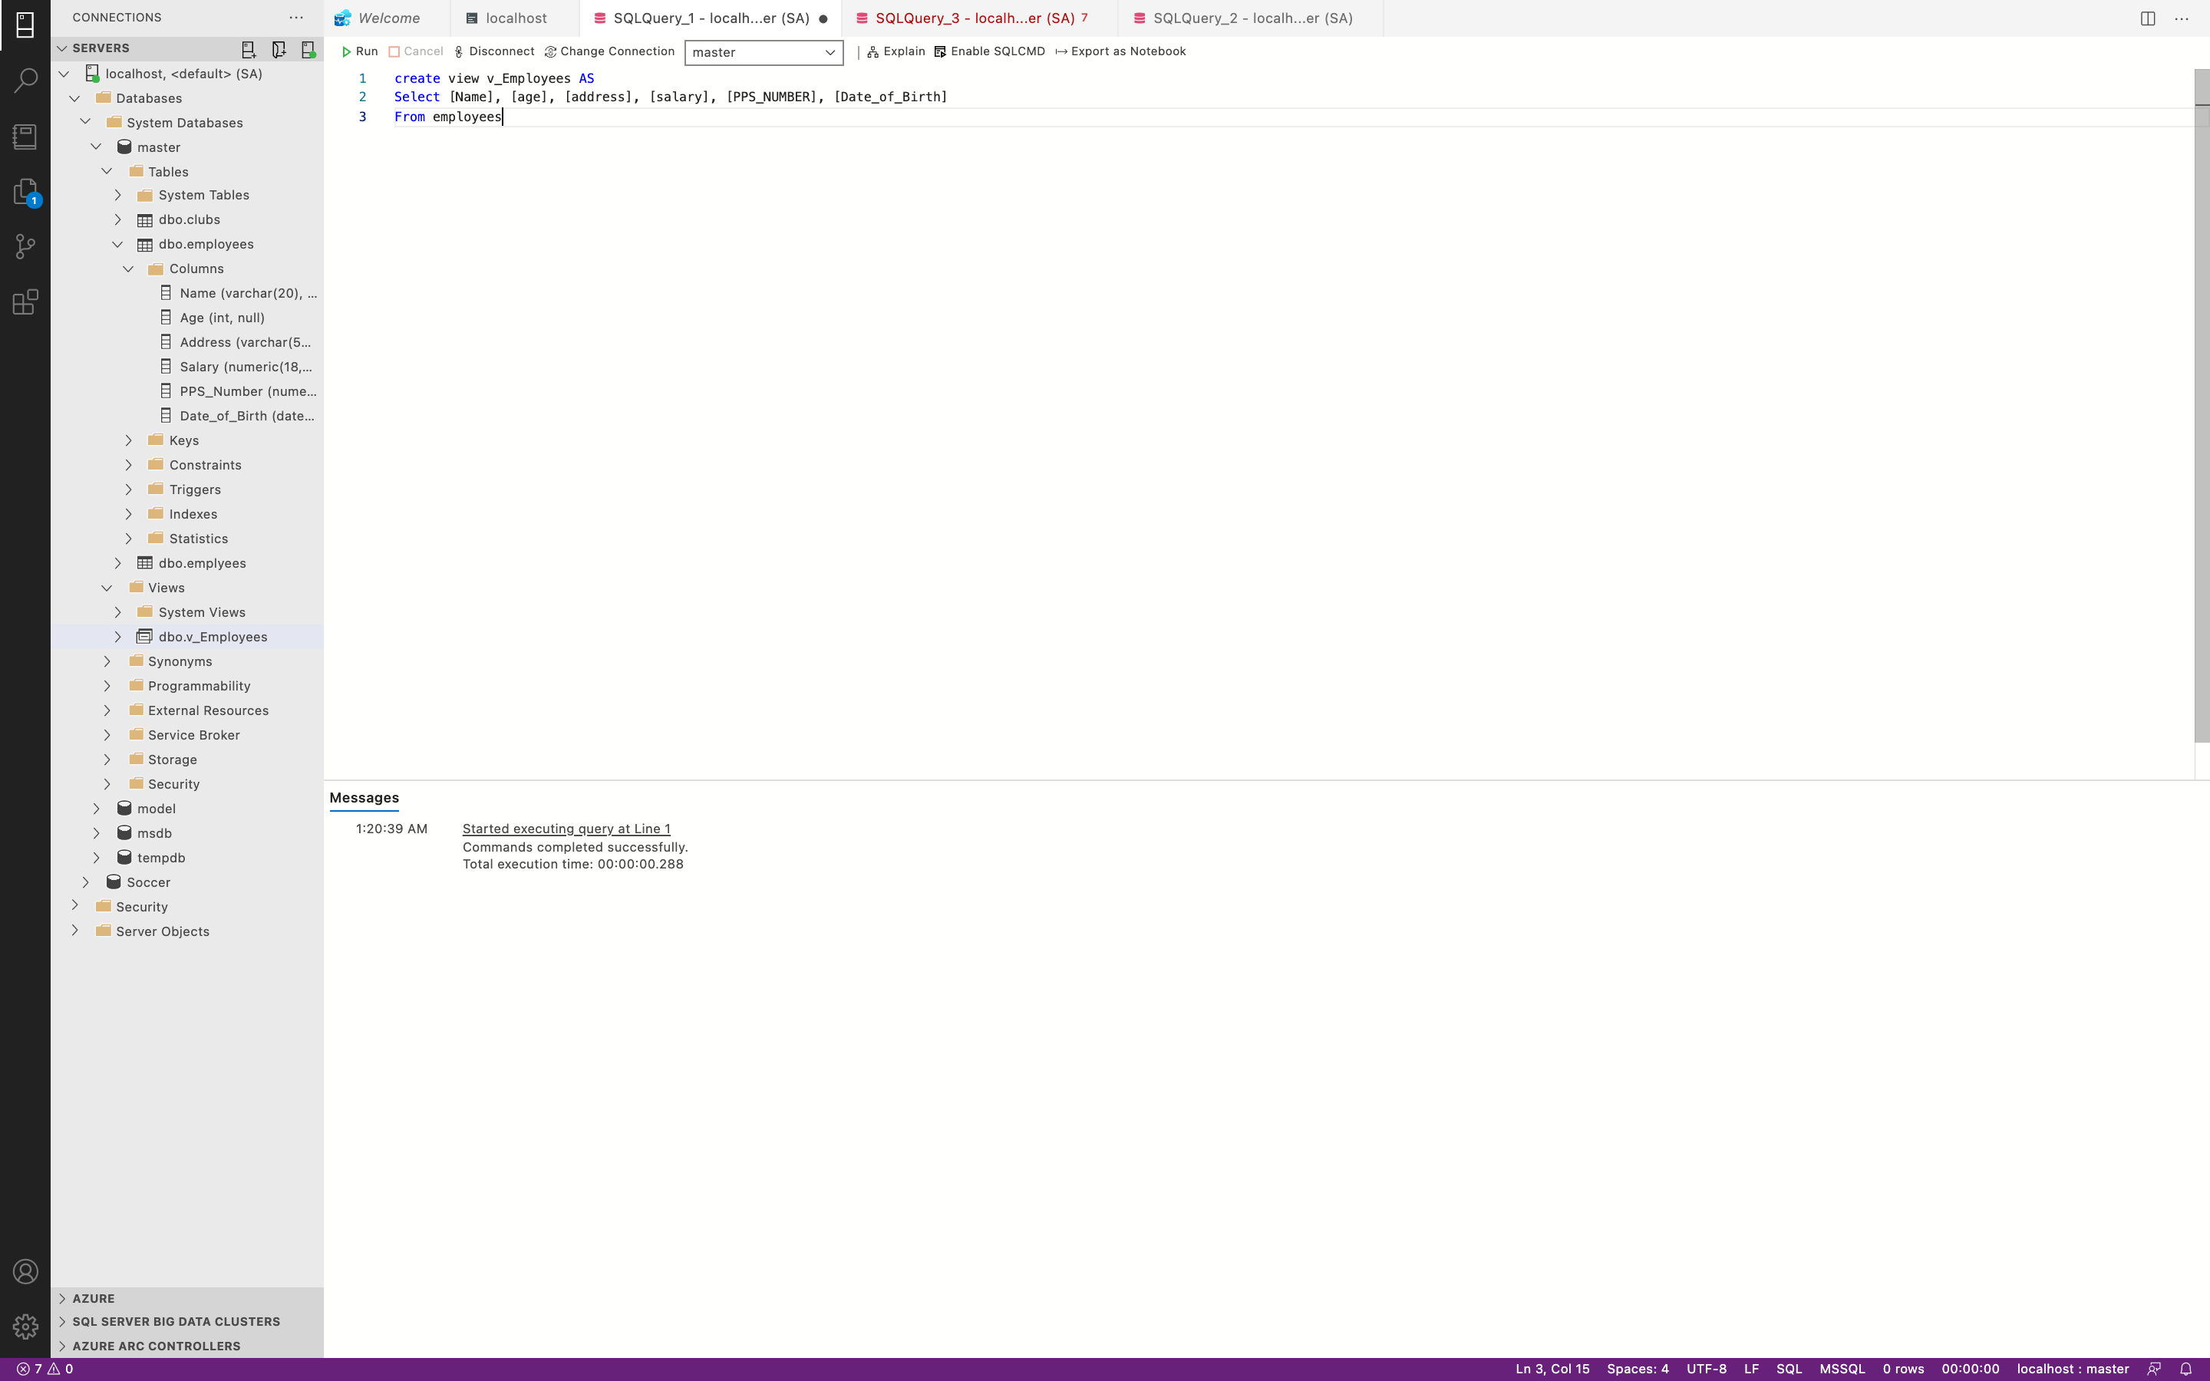

Describe the steps involved in creating a stored procedure using the graphic interface in SQL Server Management Studio.